-  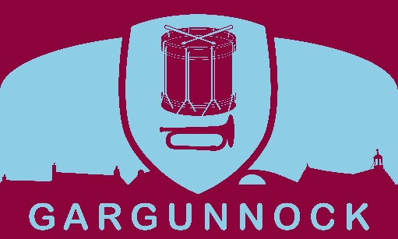 | Gargunnock Community Trust Ltd.  A registered company in Scotland (SC285574)  www.gargunnock.org | 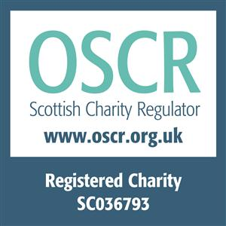

EGM
9 May 2024 @ 7.30pm
held at Gargunnock Community Centre

Present:

Trustees: Gavin Fleming, Geoff Peart, Nathan Anderton, Jill Patrick, Gill Bell, Steve Barnet, Crawford Gordon, Dan Williams, Stuart Ogg, Mairi Jackson

Members: Edmond Mansion, Jackie Campbell, Duncan Lawson.

Advisor: Lee Stevenson, Stirlingshire Voluntary Enterprise

Apologies: John Steele

SO thanked all those attending and explained that the EGM had been called to discuss the following resolutions to consider:

- the proposal to convert the Gargunnock Community Trust Ltd to a Scottish Charitable Incorporated Organisation (SCIO)
- and if that was approved by at least 75% in attendance to consider the adoption of the new draft constitution prepared by Stirlingshire Voluntary Enterprise (SVE)

GF gave a presentation outlining the background to a SCIO including the pros and cons. Lee was able to clarify various points raised by those attending.

The resolution to convert Gargunnock Community Trust Ltd to a SCIO was then put to a vote which was passed unanimously.

The discussion then focused on the draft constitution of the new body which had been prepared by SVE. After identifying various points including the actual size of the new body’s board the resolution to adopt the new draft constitution, with minor changes to be included, was put to the vote and was also passed unanimously.

GF thanked Lee for all her help and work on the draft constitution.
Lee explained the next stages in the process which was to prepare an application to OSCR (The Scottish Charities Regulator) which she would be happy to help with.

The EGM closed at 8.00pm

